Chapter 6, Solution 65.

(a) 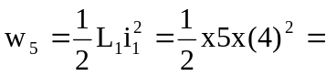 40 J
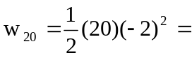 40 J
- w = w₅ + w₂₀ = 80 J
- 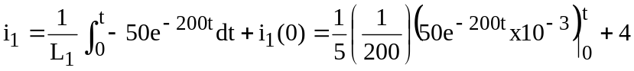
= [5x10⁻⁵(e^{-200t} – 1) + 4] A

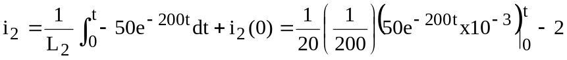
= [1.25x10⁻⁵ (e^{-200t} – 1) – 2] A

(d) i = i₁ + i₂ = [6.25x10⁻⁵ (e^{-200t}– 1) + 2] A

